**Overview:** This module will help you to convert your page content into PDF. This does not contain any code file as it will work with a javascript code along with Sitecore items. Here are the steps to make this working.

1. Go to the path (/sitecore/content/your-tenant/your-site/Settings/HTML Snippets) and using insert options, create a new HTML Snippet item and name it “Convet To PDF Script”.

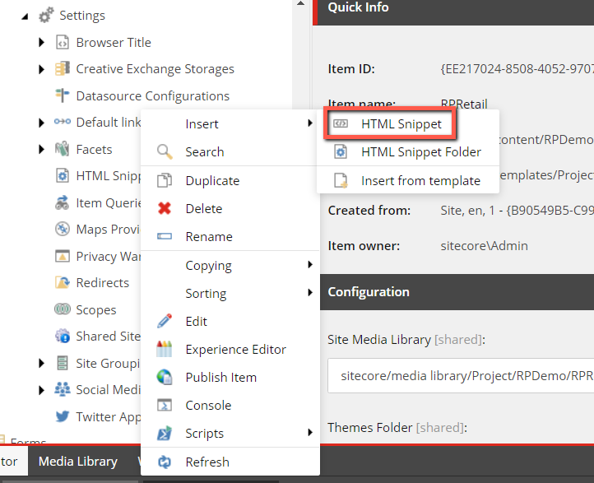

1. Then copy the javascript code, that you can find in ConvertToPDFScript.txt file and paste it in the HTML field of the item that you have created. It will look like this.

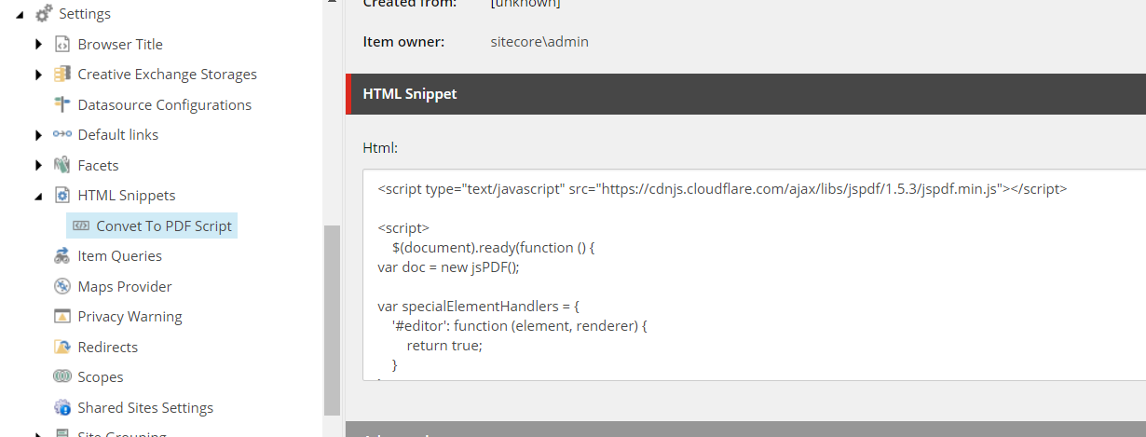

1. Go to the path (/sitecore/content/your-tenant/your-site/Presentation/Partial Designs) and using insert options, create a new Metadata Partial Design and name it “Convet To PDF”

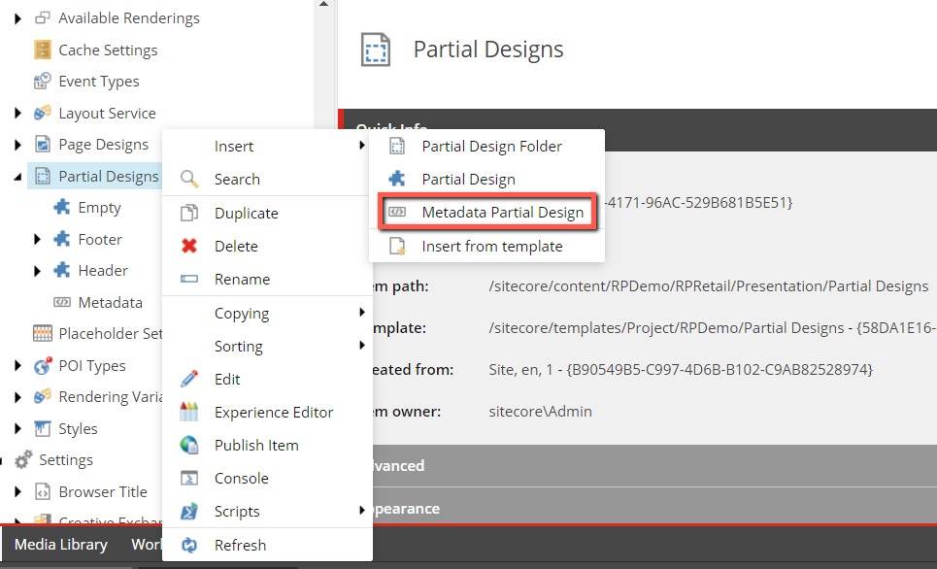

1. On this item, go to presentation details and add a new rendering called “HTML Snippet”. And associate the datasource that you have created in step 1.

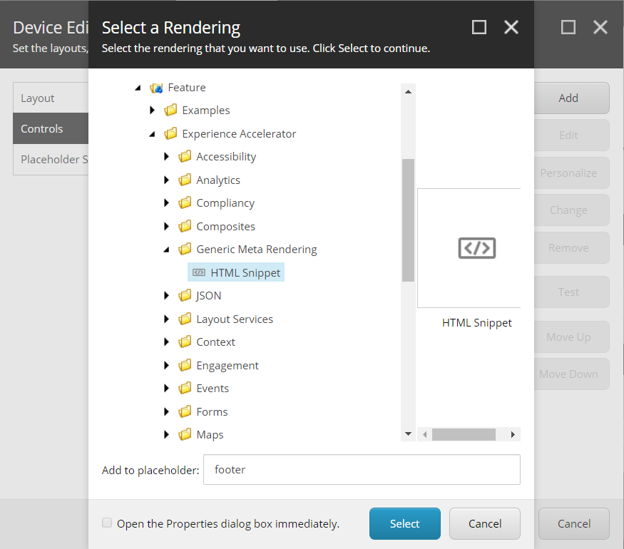

1. Go to the path (/sitecore/content/your-tenant/your-site/Data/Links) and using insert options create a Links Folder and name it “Convert To PDF Folder”

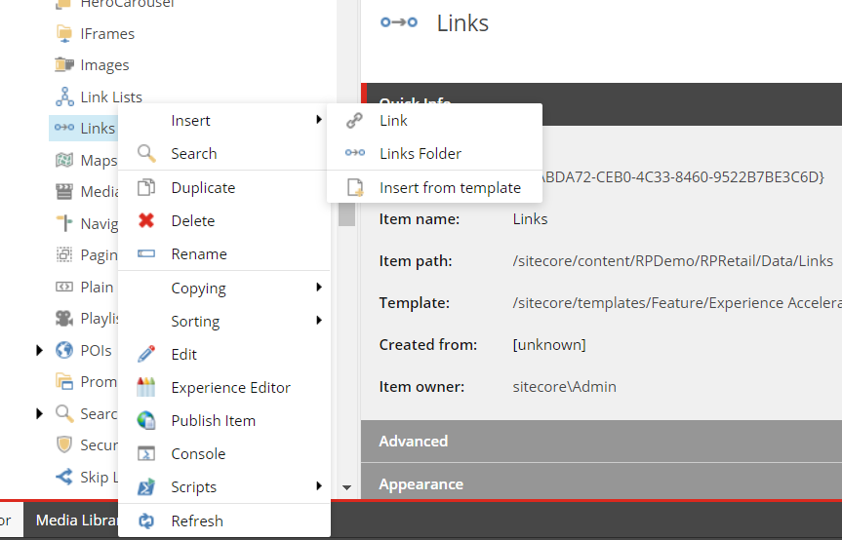

1. On this item, using insert options, create a new Link and name it “Convert To PDF”

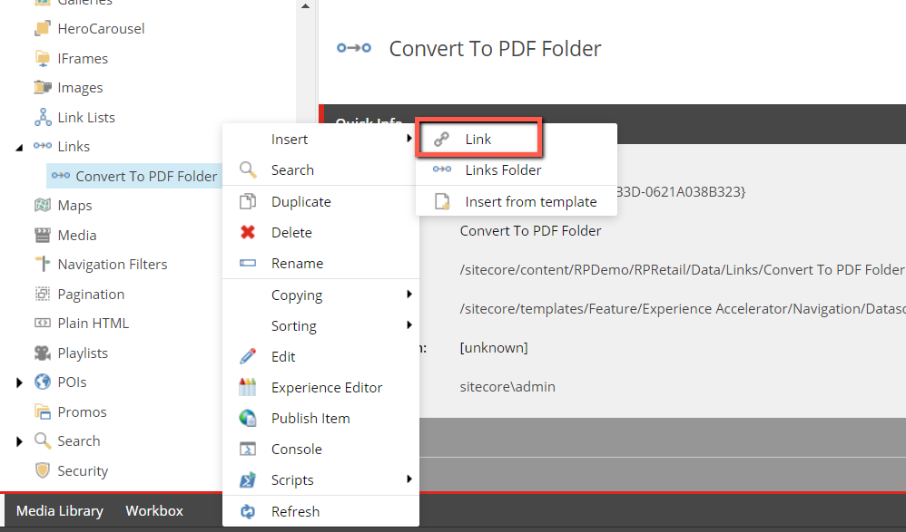

1. On this item, Go to View and check Raw Values.

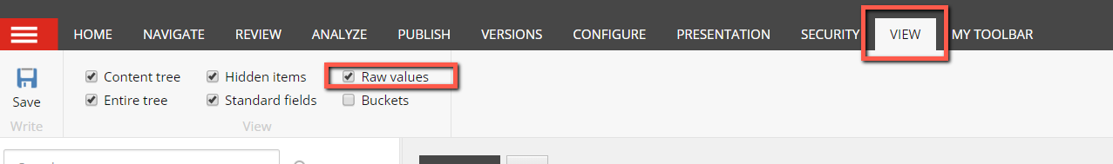

1. Then copy the link value, that you can find in Link.txt file and paste it in the Link field of the item that you have created. It will look like this.

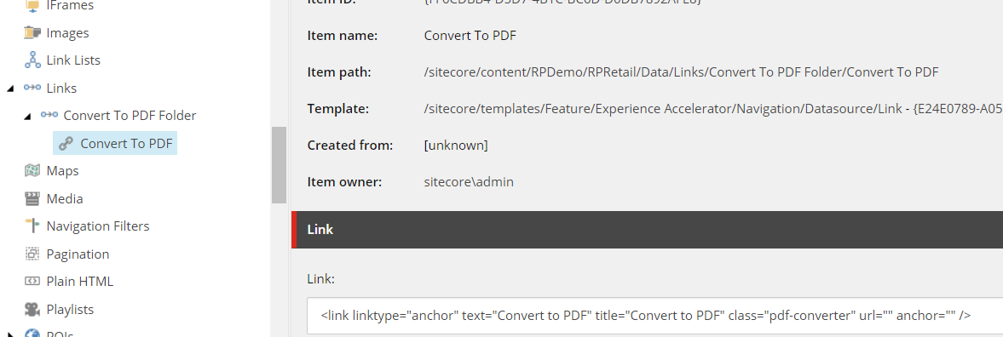

1. Uncheck the raw value check box.
2. Go to the path (/sitecore/content/your-tenant/your-site/Presentation/Partial Designs) and using insert options, create a new Partial Design and name it “PDF Link”. This is an optional step. We are just going to render the PDF Link on the page. If you have a set of partial designs, then you can put this on any place as per your design.

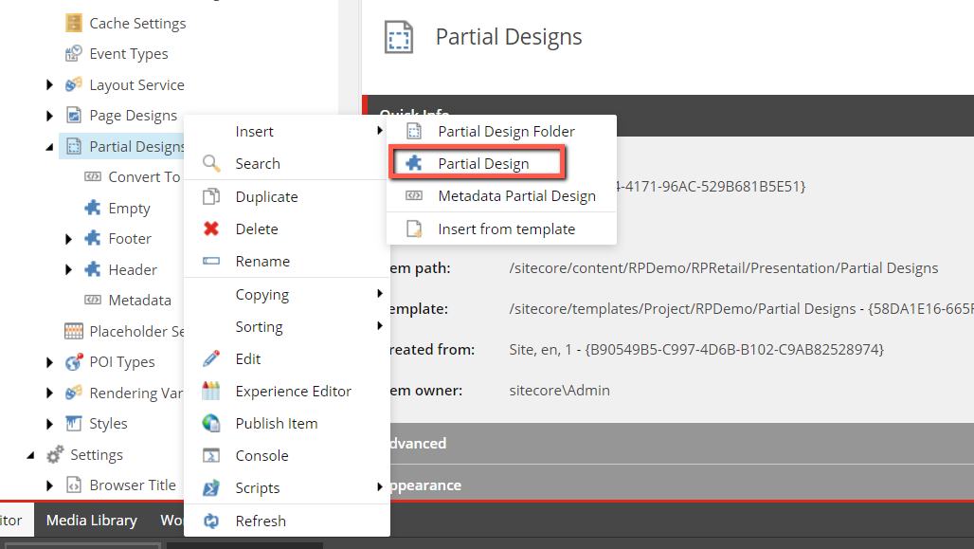

1. Using presentation details, add a new rending of Link type.

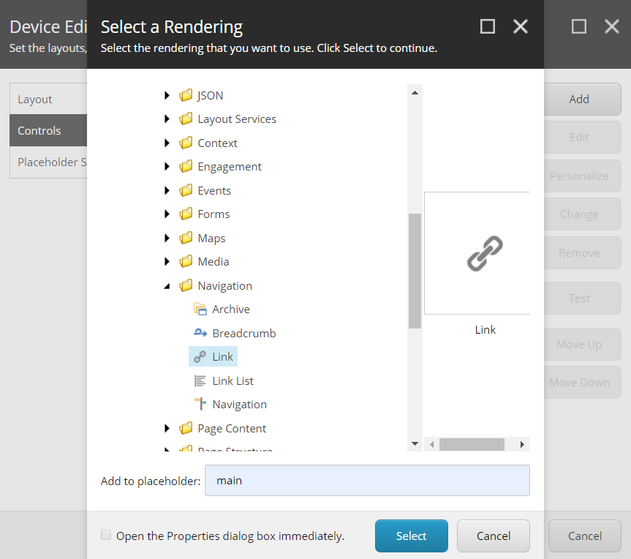

1. Associate a datasource that you have created in step 6.
2. Now finally go to your Page design and add PDF Link and Covert To PDF partial designs in it.

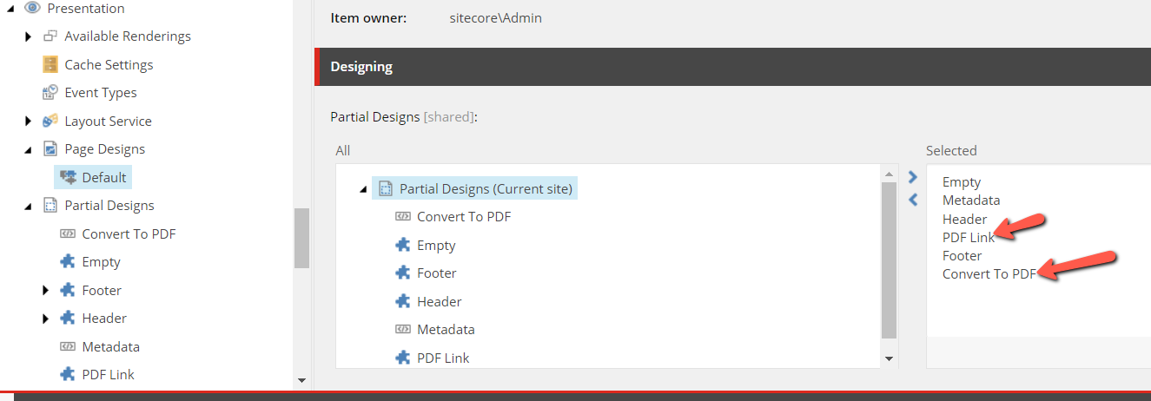

1. Once you will run the page, you will find this link and when you click on this, it will download a PDF file.

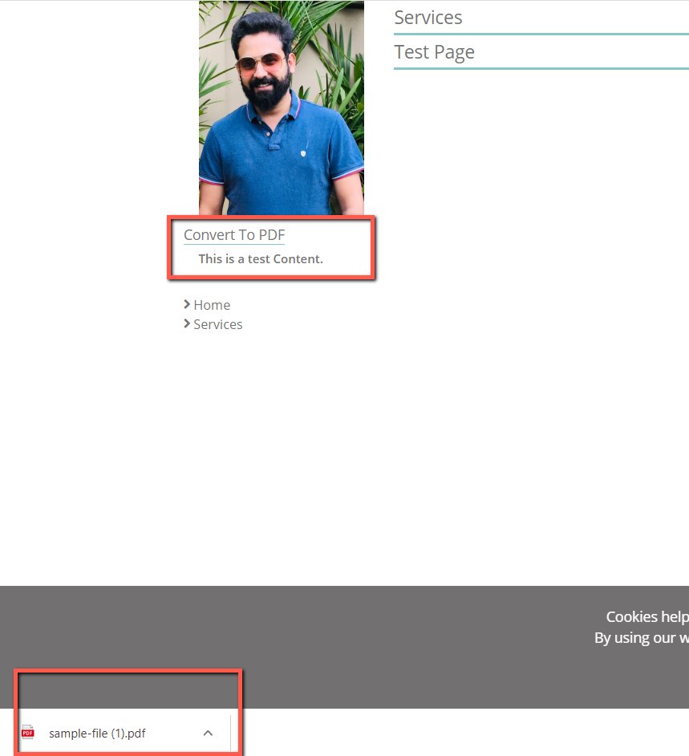

One thing, you must remember is, this script is reading the content that comes under <div class=” pdf-content”>. So whatever content you want to add in PDF, should come under this div.

You can also modify the script as per your need.

Happy Sitecoring.